Total responses: 25

Duration: 9/20 - 9/27

MemorAI Pre-product Survey

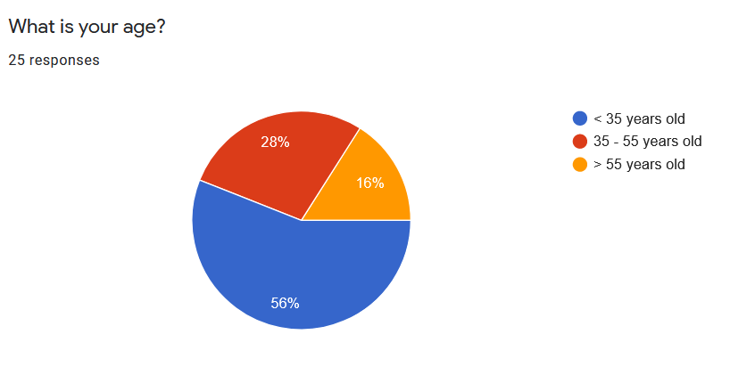

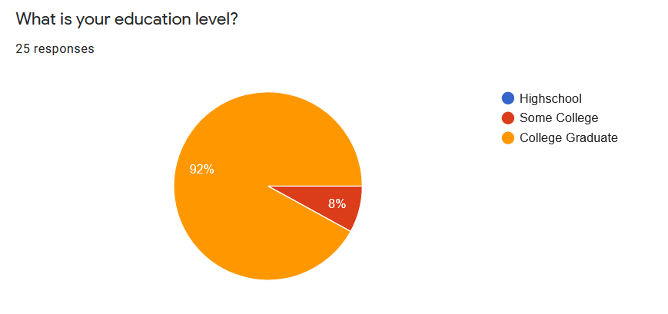

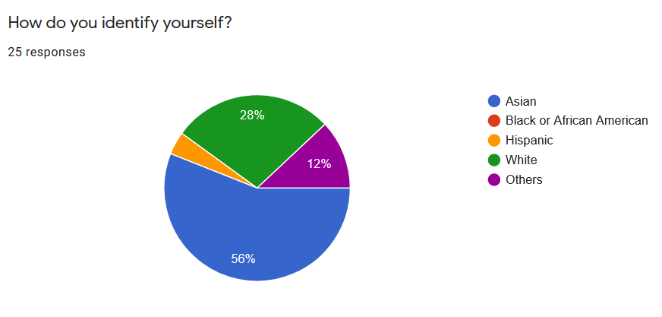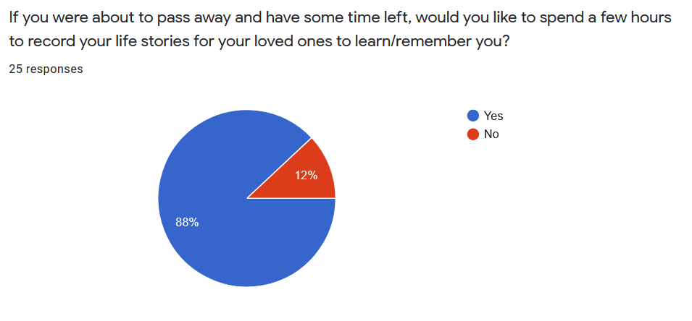

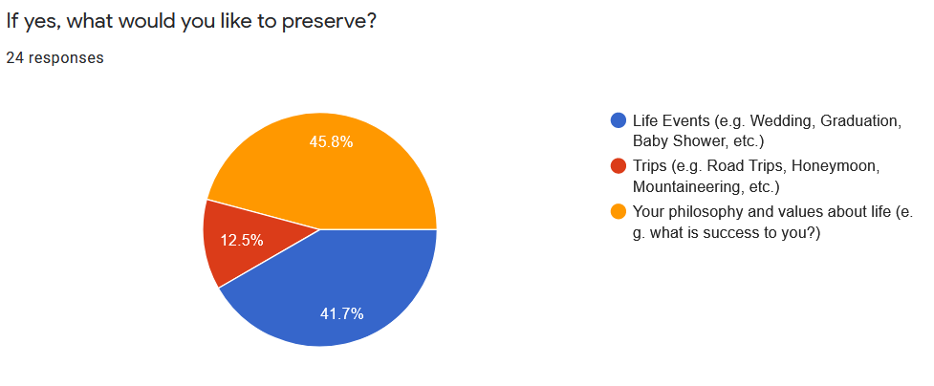

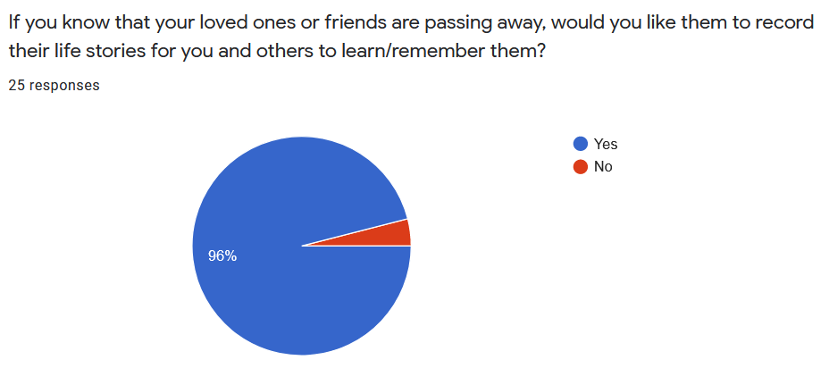

Open ended question: If there is only one thing you would like your loved ones to remember about you, what would it be?

* I would like my loved ones to remember the memories and fun times we had together/time spent together
* How I impacted their life in a positive way
* That I led a pretty interesting life
* I'd like to instill values
* The fun times and adventures we had together.
* Remember the times I have helped and supported them as many easily forget such deeds.
* When I realized who I was ... that moment when I realized I had the ability to choose what I wanted out of life - a moment ~7th grade, but which I believe exists for others too.
* something positive to remember
* How I felt about them, including how much I love them
* Some kind of positive impression or as a motivator.
* My amazing data wrangling skills. I’m actually not sure…
* To follow Jesus
* Kind-heartedness
* Approach to living and priorities in life.
* I prefer them to remember me the way they remember me. Hopefully unique for everyone.
* Willingness to help
* That they enriched my life more than they would ever know.
* How I experienced the little things in life and the particular, peculiar things I found captivating and what I saw in them
* Experiences we shared
* Laughter and silliness
* my values
* How much I love them.